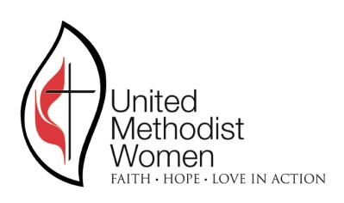
REGISTRATION FORM
LOUISIANA CONFERENCE UMW 150TH ANNIVERSARY CELEBRATION
Celebrating 150 years of putting faith, hope, and love
into action as women organized for mission.

Saturday, March 3, 2018
Alexandria First United Methodist Church
2727 Jackson St., Alexandria, LA 71301 318-443-5696
On site registration: 9:00 AM - 10:00 AM
Gathering: 10:00 AM

PRE-REGISTRATION DEADLINE DATE: February 25, 2018

Name:_______________________________________________________
Address: _____________________________________________________
City _______________________________ State_______ Zip ________
Phone (home)_________________________ cell ____________________
E-mail________________________________________________________
Name of church _______________________________________________
District ______________________________________________________
CHECK ALL THAT APPLY
( ) Conference officer – Specify __________________________________
( ) Conference Executive Committee ______________________________
( ) District officer – Specify _____________________________________
( ) Local member ( ) Local officer – Specify _______________________
( ) Missionary, UM Minister, or Deaconess _________________________
Registration fee: $ 15.00
MAKE CHECK FOR REGISTRATION PAYABLE TO:
LOUISIANA CONFERENCE UMW
Mail with check to UMW Conference Treasurer: Sandie Webb, 5932 College Dr.,
Baton Rouge, LA 70806. Phone: 225-771-8638 email: sandiewebb1@gmail.com
Hotel: Home2Suites, 3800 Alexandria Mall Dr., Alexandria, LA 71301, 318-704-6451
Rate: $ 95 plus tax. Please make your reservation by Feb. 17 to receive the discount.

