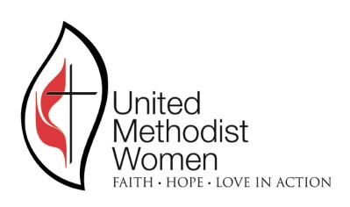
REGISTRATION FORM
LOUISIANA CONFERENCE UMW ANNUAL MEETING
“Celebrating Our Faithful Future”

Friday & Saturday, October 12 &13, 2018
FIRST UNITED METHODIST CHURCH, Lafayette
703 Lee Ave. Lafayette, La. 70501 Phone 337-233-3811
On-site registration: 10:00-12:00 a.m.
Gathering: 1:00

PRE-REGISTRATION DEADLINE DATE: September 22

Name:_______________________________________________________
Address: _____________________________________________________
City _______________________________ State_______ Zip ________
Phone (home)_________________________ Cell ____________________
E-mail________________________________________________________
Name of church _______________________________________________
District ______________________________________________________

CHECK ALL THAT APPLY
( ) Conference officer – Specify __________________________________
( ) District officer – Specify _____________________________________
( ) Local member ( ) Local officer – Specify _______________________
( ) Missionary, UM Minister, or Deaconess _________________________
( ) (New time this year) DELT Training will be held on Friday morning at 10:30

Registration fee: $15 Banquet: $35 (Banquet-Pre-registration Only)

MAKE CHECK FOR REGISTRATION PAYABLE TO:
LOUISIANA CONFERENCE UMW

Mail with check to UMW Conference Treasurer: Sandie Webb, 5932 College Dr.,
Baton Rouge, LA 70806. Phone: 225-771-8638 email: sandiewebb1@gmail.com

Hotel: DoubleTree by Hilton Lafayette, 1521 W Pinhook Rd., 337-235-6111
Rate: $109.00 plus tax. Please make your reservation by 9/11/18 to receive the discount.

