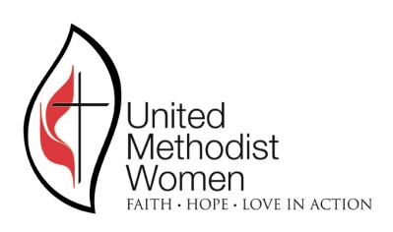
REGISTRATION FORM
LOUISIANA CONFERENCE UNITED METHODIST WOMEN

SPIRITUAL GROWTH RETREAT
March 14, 2020 9:30-1:00

“God’s Spirit Is With Us Always”
Scripture Isiah 11:1-3

Cornerstone United Methodist Church
5276 Bullard Ave., New Orleans, 70128
On-site registration: 9:00

PRE-REGISTRATION DEADLINE DATE: March 7, 2020

Name: ______________________________________________________
Address: ____________________________________________________
City _______________________________ State_______ Zip ________
Phone (home)_________________________ cell ____________________
E-mail_______________________________________________________
Name of church _______________________________________________
District ______________________________________________________

CHECK ALL THAT APPLY
( ) Conference officer – Specify _________________________________
( ) District officer – Specify _____________________________________
( ) Missionary, UM Minister, or Deaconess ________________________

Pre-Registration fee: $15 (On-site fee-$20)
Make Check Payable to: LOUSIANA CONFERENCE OF UMW

Mail your form with check to UMW Conference Registrar:
Debbie Cottrell, 104 Phillip Ave., Lafayette, LA 70503. Phone: 337-232-5728
Conference Treasurer for questions: sandiewebb1@gmail.com

Hotel: COMFORT SUITES, 7051 Bullard Ave, New Orleans, LA 70128
Rate: $139-King, $149-Double plus tax. Call:504-244-1414 Please make your reservation by March 1st to receive the discount.

